(Set 36) – III Semester

Attention: Students of third semester MCA

Date: 27/01/2026

The students of the PG Degree Programme have to submit their Assignments I & II on or before 22/02/2026. Further, the students are advised to adhere to the instructions communicated through e-mail/ notice boards from time to time.
Note:

Assignments shall be submitted to the CDE STAFF (Set - 36), CDE, Anna University, Chennai - 25 during Break Hours.

DIRECTION TO THE STUDENTS:

- Last date for submission of Assignment-I & II, is 22 February 2026
- Submit subject-wise assignments (No need to stick file)
- Use the template for each First page (Top Sheet) of the assignment
- All the assignments should be in the student’s own handwriting
- Each assignment should be of a minimum of five pages of A4 size paper.
- Each student should submit the assignments of all their subjects at a stretch at the same time.
- No request for delayed submission shall be entertained
- Attach one copy of the Acknowledgement printout along with Assignments I & II.

Co-ordinator
Set-36

(SET - 36)

MCA

III SEMESTER – ASSIGNMENT – I& II

NAME :

ROLL NO :

Mobile No :

SUBJECT CODE :

SUBJECT NAME :

CDE STUDY CENTRE

ANNA UNIVERSITY :: CHENNAI 600 025

III SEMESTER SET - 36 - ASSIGNMENT – I & II
STUDENT ACKNOWLEDGEMENT COPY

Name : Roll No.:

Course:

S.No. | Subject Code & Name | No. of Assignments Submitted
1
2
3
4
5
6
7
 | Total No Assignments

Signature of the Student Signature of the CDE Staff
M.C.A Semester – III

DMC8301 DATA SCIENCE
Assignment - 1
1. Explain Univariate Analysis.
2. Explain Regression Modeling.
Assignment –2
1. Explain Hadoop.
2. Explain Stream Concept.

DMC8302 Multimedia Systems and Applications

Assignment – I

1. Write a short note on Cognition and Medium of consumption.
2. Write about text characteristics, standards, and formats.
3. Explain in detail about K-D trees and R-trees.
4. Write in detail about various I/O devices that are used in Multimedia Systems.
5. Write in detail about Multimedia authoring tools features, applications, and presentations.
Assignment – II

1. Explain RLE and Huffman coding Text Compression algorithm with a suitable example.
2. Apply LZW compression on String ABABBABCABABBA, Explain the steps in detail on how compression is done.
3. Explain how Jpeg Compression works.
4. Write short notes on RTP, RTCP, RSVP, and RTSP.
5. Explain in detail about the Interactive E-Learning Application.

DMC8303 ACCOUNTING AND FINANCIAL MANAGEMENT FOR APPLICATION DEVELOPMENT
ASSIGNMENT-1
- What is Financial Accounting? Explain in detail accounting concepts and conventions.
- Bring out the factors affecting depreciation and Causes of Depreciation.
- Difference between Journal and Ledger.
ASSIGNMENT-2
- The following balances were extracted from the books of Thomas as on 31st March, 2018
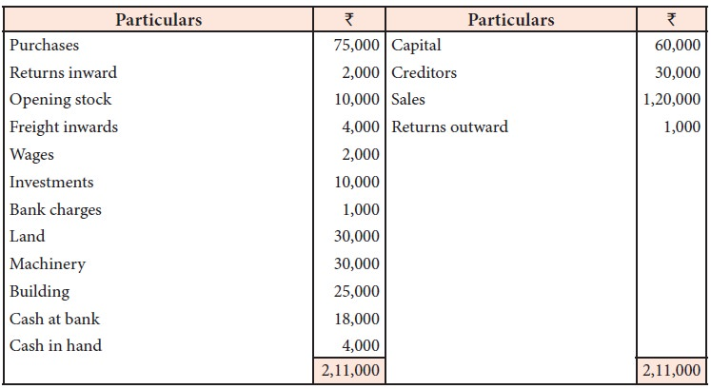
Additional information:
i. Closing stock Rs. 9,000
ii. Provide depreciation @ 10% on machinery
iii. Interest accrued on investment Rs. 2,000

Prepare trading account, profit and loss account and balance sheet.

- The Profit of the firm for the last five years are 2002 Rs. 20,000; 2003 Rs. 16,000; 2004 Rs. 24,000; 2005 Rs.8000; 2006 Rs. 12,000. Calculate the goodwill of the firm.

DMC8018 DATA MINING AND DATA WAREHOUSING TECHNIQUES
Assignment 1
1. Write short notes on multi-dimensional data models.
2. Explain the various operations performed on OLAP.
3. Write short notes on the KDD process.
4. Apply the Apriori algorithm to the following data set and derive the association rules. The set of items is {Apple, litchi, orange, butter fruit, vanilla, mango, grapes}. The minimum support value is 0.3. (Use with candidate key method).
Trans ID | Items Purchased
T101 | Apple, litchi, oranges
T102 | Apple, butter fruit
T103 | Butter fruit, vanilla
T104 | Apple, litchi, oranges
T105 | Mango, oranges
T106 | Mango
T107 | Mango, butter fruit, vanilla, apple
T108 | Apple, litchi, grapes, oranges
T109 | Grapes, Vanilla
T110 | Apple, litchi
T111 | Butter fruit, apple
T112 | Grapes, oranges
T113 | Litchi, oranges
T114 | Apple, litchi, oranges
T115 | Butter fruit, mango, vanilla

Assignment 2
Answer the following questions:
- Differentiate between Classification and Prediction.
- Find the decision tree for the following data set. (Use ID3 method)

T_id | Homeowner | Annual Income | Marital Status | Default borrower
T101 | Yes | 125k | Single | No
T102 | No | 100k | Married | No
T103 | No | 70k | Single | No
T104 | Yes | 120k | Married | No
T105 | No | 95k | Divorced | Yes
T106 | No | 60k | Married | No
T107 | Yes | 220k | Divorced | No
T108 | No | 85k | Single | Yes
T109 | No | 75k | Married | No
T110 | No | 90k | Single | Yes

- How can classification be done by using the Back Propagation method?
- Define cluster analysis. What are the various types of data used in it?

DMC8019 DATA VISUALIZATION TECHNIQUES

Assignment 1
1. Describe in detail about the common display types and when to use which type.
2. Explain about the data preprocessing with examples.
3. Explain the Eight Visual Variables with suitable diagrams.
4. Write about how to understand the Visualization of Geospatial data with an example (Note: Answer any two questions for 2*10 = 20 marks)
Assignment II
1. Explain the Cognitive Issues in Data Visualization.
2. What are the Key goals in the visual design process and explain that?
3. Explain any one dashboard case study
i. Sales dashboard
ii. Marketing analysis dashboard.
4. Explain about the Modern integrated visualization systems

DMC8007 Software Security

Assignment 1
- Discuss memory-based attacks in detail.
- Explain the secure software development life cycle(SDLC).
- Discuss in detail OWASP Top 10 vulnerabilities.

Assignment II
- Discuss common web application vulnerabilities.
- Explain the phases of penetration testing.

DMC8025 Blockchain Technologies
Assignment 1
- Explain the concept of decentralization using Blockchain. How does Block chain enable full ecosystem decentralization? Discuss various platforms that support decentralization.

- Describe the Bitcoin network architecture in detail. Explain the role of digital keys, addresses, transactions, mining, and wallets in the Bitcoin ecosystem.

Assignment II
- Discuss the Ethereum network and its components. Explain the Ethereum programming languages, runtime byte code, blocks, fee schedule, and supporting protocols.(10)

- 4. Compare and contrast different alternative blockchains such as Kadena, Ripple, Rootstock, Quorum, and Tendermint. Discuss their scalability, privacy, and other challenges in Blockchain technology.(10)

**************

